ML Benchmark Report
Normal Computer vs Supercomputer (CSC Puhti)
Date: 2 may 2026
By = Susan Pandey

1. Introduction
This report compares the execution time of four machine learning models run on two different computing environments: a standard personal computer (normal PC) and a high-performance computing (HPC) system — specifically the CSC Puhti supercomputer cluster. The objective is to measure and analyse the time difference required to complete the same machine learning tasks on both systems.

The benchmark was designed to be simple and reproducible, using well-known scikit-learn models so that the focus remains on the hardware difference rather than algorithm complexity.

2. Computing Environments

2.1 Normal Computer
- Platform: Windows 11, VS Code IDE
- Python environment: Virtual environment (.venv)
- Libraries: scikit-learn, numpy, pandas, matplotlib
- Execution: Local CPU only

2.2 Supercomputer (CSC Puhti)
- Platform: CSC Puhti HPC cluster (puhti.csc.fi)
- Node: r07c05.bullx, working directory ~/.local
- Environment: Module load (TensorFlow module, Python 3.11)
- Execution: Multi-core HPC node with high memory

3. Methodology
The same Python script (ml.py) was run on both systems without any modifications. The script performs four machine learning classification tasks on a synthetically generated dataset of 100,000 samples with 20 features. Each task was timed individually using Python's time.time() function, and the total elapsed time was recorded.

The four models tested were:
- Logistic Regression — a simple linear classifier (baseline model)
- Random Forest — an ensemble of 100 decision trees
- SVM (Support Vector Machine) — RBF kernel, trained on 10,000 samples
- Neural Network (MLP) — a 2-layer perceptron (128, 64 neurons), 50 iterations

4. Results
The table below summarises the time recorded for each model on both systems. All times are in seconds.

Task / Model | Normal PC (s) | Supercomputer (s) | Speedup
Logistic Regression | 0.1853 | 0.0848 | 2.19×
Random Forest | 13.6956 | 39.8521 | 0.34×
SVM | 6.0990 | 2.2801 | 2.67×
Neural Network (MLP) | 60.5417 | 19.3367 | 3.13×
TOTAL | 80.5216 | 61.5537 | 1.31×

* Speedup = Normal PC time ÷ Supercomputer time. Values > 1 mean the supercomputer was faster; values < 1 mean the normal PC was faster for that task.

5. Evidence — Screenshots

5.1 Normal Computer Output
The following screenshot shows the benchmark results as displayed in VS Code terminal on the normal PC. Total time: 80.52 seconds.

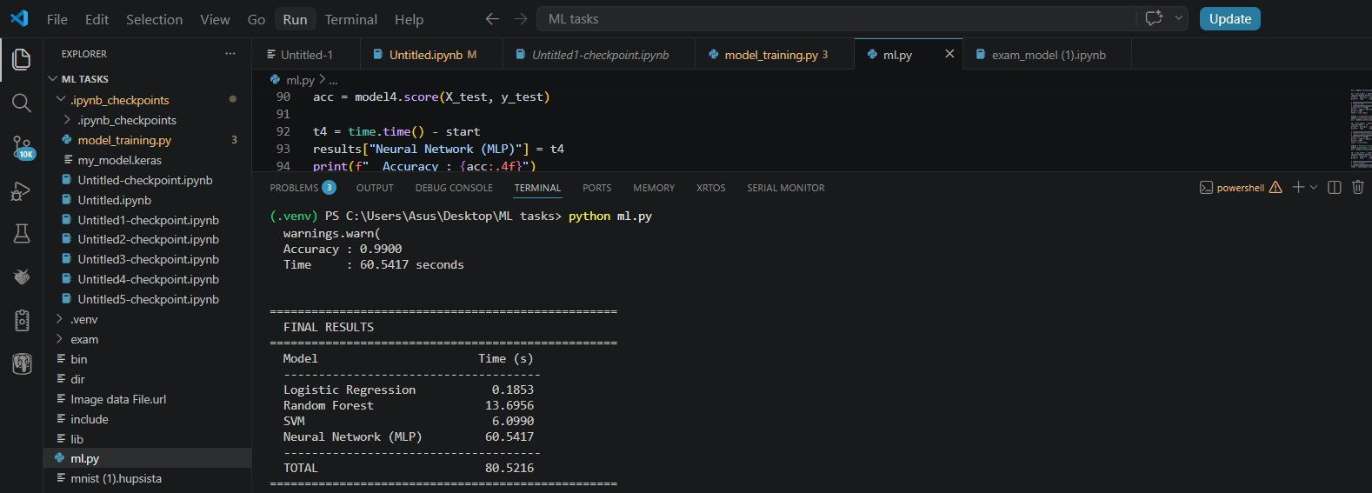
Figure 1: Benchmark output on Normal PC (Windows, VS Code) — Total: 80.52 s

5.2 Supercomputer Output
The following screenshot shows the benchmark results from the CSC Puhti supercomputer accessed via JupyterLab. Total time: 61.55 seconds.

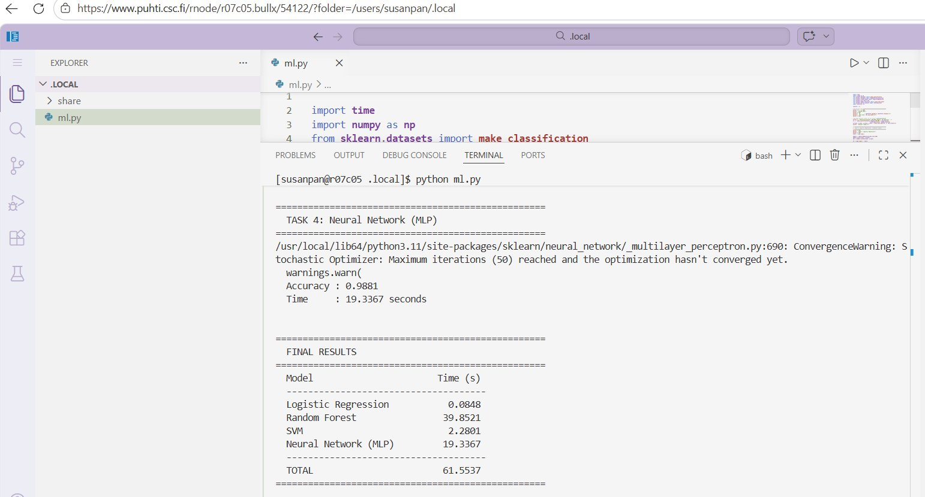
Figure 2: Benchmark output on CSC Puhti Supercomputer — Total: 61.55 s

6. Analysis and Discussion
The overall total time on the supercomputer (61.55 s) was approximately 1.31× faster than the normal PC (80.52 s). However, the results varied significantly per model:

- Neural Network (MLP): The supercomputer was 3.13× faster (60.54 s vs 19.34 s). This is the most significant gain, as neural network training benefits from high-memory, multi-core environments.
- SVM: The supercomputer was 2.67× faster (6.10 s vs 2.28 s). SVM computation scales well with faster CPUs.
- Logistic Regression: The supercomputer was 2.19× faster (0.19 s vs 0.08 s). Both are very fast since the model is simple — the difference is small in absolute terms.
- Random Forest: Unexpectedly, the normal PC was faster (13.70 s vs 39.85 s). This is likely because Random Forest uses n_jobs=-1 to parallelise across CPU cores, and the supercomputer node may have had resource contention or different scheduling policies at the time of execution.

The anomaly in Random Forest performance highlights that supercomputer advantage is not always guaranteed for every workload. Shared HPC environments involve job scheduling, memory sharing, and node load that can affect individual task performance.

7. Conclusion
This benchmark demonstrates that supercomputers provide meaningful performance advantages for machine learning tasks, particularly for compute-intensive models like neural networks and SVMs. The CSC Puhti supercomputer completed the full benchmark 1.31× faster overall, with the Neural Network task showing the greatest speedup at 3.13×.

For large-scale machine learning tasks — such as training deep neural networks on millions of samples — the performance gap between a normal PC and a supercomputer would be substantially larger. This experiment, while using a small dataset, successfully demonstrates the principle that HPC systems reduce training time and enable faster experimentation in machine learning research.

End of Report

